European consortium to develop new quantum clocks

Ultra-precise and easily transportable clocks will open door to new technological and scientific applications

The European Union has awarded 10 million euros to a European consortium of universities and businesses to develop ultra-precise and easily transportable optical atomic clocks. The iqClock consortium will build these flagship quantum clocks by using ground-breaking developments in quantum mechanics and by bringing together the latest know-how in science and industry. These clocks, which will be incredibly accurate but small enough to be easily transported, will open the door to new technological and scientific applications.

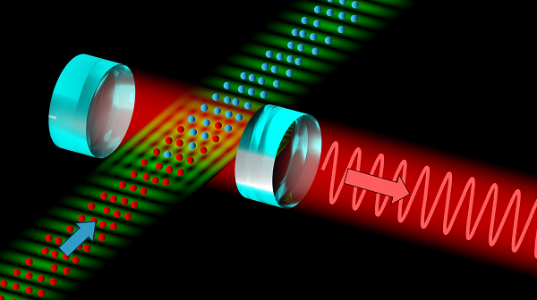  Figure 1. Schematic drawing of the superradiant optical clock that will be developed by the iqClock consortium. The input (blue arrow) is a continuous stream of ultracold strontium atoms; the output (red arrow) is a laser beam with a highly precise frequency used as reference for an optical clock. (Images available in larger resolution.) | 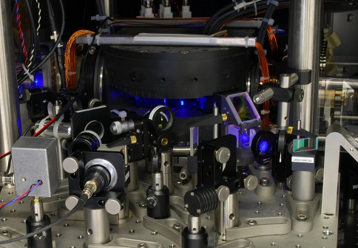  Figure 2. An ultracold cloud of strontium atoms in a vacuum chamber surrounded by electromagnets and laser cooling optics as used in the iqClock research. (Images available in larger resolution.)

The iqClock programme is the brainchild of physicists Florian Schreck, from the University of Amsterdam, and Yeshpal Singh, from the University of Birmingham. The consortium arose after both researchers decided to work on a shared goal: to improve and simplify time keeping. In some laboratories, ultra-precise clocks, so-called optical atomic clocks, already exist. These clocks are the most precise scientific instruments ever created – if they were to run for the entire age of the universe, fourteen billion years, they would go wrong by only a second. As nice as such optical atomic clocks are, though, they have two major drawbacks – they are extremely difficult to build and moreover are large, heavy and not very robust. Schreck and Singh set out to build a consortium of European universities and businesses with the aim of making ultra-precise optical atomic clocks available to society.

Simpler and smaller
Recent developments show that the concept of an optical atomic clock can be simplified. The current optical clocks use the vibrations of atoms to set a very precise frequency with which the clock ticks. This frequency is then transferred to an optical laser – hence the name ‘optical clock’. Tuning the laser frequency to that of the atoms is not easy, but physicists have now found a way to implement the idea more easily – by simply letting the vibrating atoms themselves form the laser beam – a construction that has been dubbed a superradiant laser. The double use of the same atoms should make it much easier to construct optical atomic clocks, as the atoms provide light that is not only very stable, but also automatically has the correct frequency.
This idea would remove the first drawback of optical clocks – the fact that they are so complicated – but so far, superradiant clocks have never been built. However, the main building block, a continuous source of ultracold strontium atoms, only a few millionths of a degree above absolute zero, was recently realised by Florian Schreck’s team. At the same time, Yeshpal Singh had suggested an initiative to develop industrial optical atomic clocks, planning to remove the second drawback – the large size and fragility of the existing clocks. Thus, nothing seemed to prevent atomic clocks from starting to play a role in our everyday life.

Building a consortium
Turning a proof of concept into actual working clocks is a long process though, one that requires close collaboration between science and industry. Schreck, Singh and Kai Bongs, Birmingham physicist and director of the UK National Hub for sensors and metrology, decided to team up with a large group of colleagues from Torun, Copenhagen, Vienna and Innsbruck to see if such a collaboration could be realised. On the industry side, several partners were equally interested in developing the ideas: Teledyne e2v, Chronos and British Telecom in the UK, Toptica in Germany, NKT Photonics in Denmark, and Acktar in Israel. With such substantial interest among both academic and industrial partners, the decision was made to set up a broad European research consortium with the goal of bringing optical clocks closer to the market. The consortium was subsequently financed as one of the first projects in the context of the Flagship Initiative for quantum technologies, a broad 10-year programme funded by the European Union to the tune of one billion euros. Out of this budget, the iqClock consortium, as the new collaboration was named, was funded for the next three years for a total of 10 million euros.

Navigation, geology and astronomy
The consortium’s aim is to make the optical clock technology fully transportable, so that by the end of the 10-year programme it can be used in satellites, for example. This is not an easy process, but the benefits are enormous. Once the new clocks have become commonplace, they can be used to increase navigation system precision to the scale of centimetres, which would revolutionise the way in which we measure the Earth. But one can also look up instead of down: in astronomy, atomic clocks are used to synchronise telescopes all over the planet into what is effectively one giant telescope the size of Earth. Transportable optical clocks are also great for detecting gravitational waves by using satellites that are many thousands of kilometres apart. A more practical application lies in better synchronisation of telecommunication networks, increasing their performance. And then, of course, there is always the unexpected: when new technology becomes available on a wide scale, industry will inevitably find novel ways to employ it.
As Schreck himself phrases it: ‘Ten years from now, we will probably still be late for appointments with clients, but super-precise clocks may very well have penetrated society and changed the way we look at our planet and the universe.’

For further information, an extended version of this press release is available at www.iqclock.eu/media.
Press contact: Florian Schreck, F.Schreck@uva.nl. (Contact details not for publication.)
On 25 October, the EC Communication Office sent out a separate press release about the Quantum Flagship initiative. If you would like to receive that press release, please contact Camelia Vajeu, camelia.vajeu@ec.europa.eu.

